MODULE: 4.1 (C++ Basic)

1.WAP to print “Hello World” using C++
Ans:-
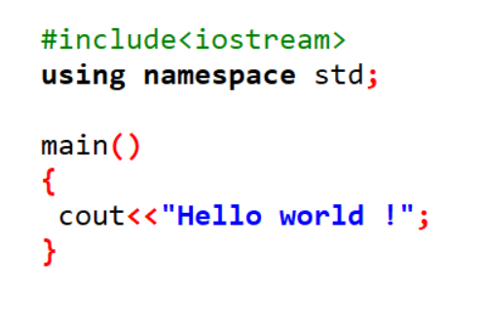
2. What is OOP? List OOP concepts
Ans:- Object-Oriented Programming (OOP) is a programming paradigm that uses "objects" to design and develop applications. An object can be a data structure that contains data (in the form of fields, often known as attributes or properties) and code (in the form of procedures, often known as methods or functions). The main aim of OOP is to increase the flexibility and maintainability of programs by making them more modular.
List OOP concepts
- Classes and Objects:
- Class: A blueprint for creating objects. It defines a type and contains data members (variables) and member functions (methods).
- Object: An instance of a class. It is a concrete entity based on the blueprint provided by the class.

- Encapsulation:
- Encapsulation is the bundling of data (variables) and methods (functions) that operate on the data into a single unit or class. It also restricts direct access to some of the object's components, which is a means of preventing unintended interference and misuse of the data.
- Abstraction:
- Abstraction means hiding the complex implementation details and showing only the essential features of the object. In C++, abstraction is achieved using classes and abstract classes.
- Inheritance:
- Inheritance is a mechanism by which one class (derived class) can inherit properties and behaviors (methods) from another class (base class). It allows for code reusability and the creation of a hierarchical relationship between classes.
- Polymorphism:
- Polymorphism allows objects of different classes to be treated as objects of a common superclass. It enables a single interface to represent different underlying forms (data types). In C++, polymorphism is achieved through function overloading, operator overloading, and virtual functions (runtime polymorphism).

3. What is the difference between OOP and POP?
Ans:- The difference between(OOP) Object-Oriented Programming and (POP) Procedural-Oriented Programming lies in their approaches to structuring and organizing code. Below are the key distinctions between the two paradigms:
1. Programming Approach:
- OOP (Object-Oriented Programming):
  - OOP is based on the concept of "objects" which can encapsulate data and methods that operate on the data.
  - It emphasizes modularity and reusability, making it easier to manage complex software systems.
- POP (Procedural-Oriented Programming):
  - POP is based on the concept of functions or procedures, which are a series of computational steps to be carried out.
  - It follows a top-down approach where the problem is broken down into a sequence of procedures or functions.
2. Data and Function Handling:
- OOP:
  - Data and functions are bundled together into objects. Objects are instances of classes, which are blueprints defining the structure and behavior.
  - OOP emphasizes data security through encapsulation, meaning data is typically hidden within objects and only accessible through methods.
- POP:
  - Data is typically separate from functions. Functions operate on data, and the data is passed between functions.
  - Data can be more exposed, and global data is often used, making it less secure and harder to manage as the program grows.

